Title of the Manuscript Times New Roman 14 Bold Centre Aligned

First Author Name¹, Second Author Name¹, Third Author Name²
¹Department of XXXXX, College of Engineering and Technology, Place, Country
²Department of XXXXX, College of Engineering and Technology, Place, Country
Email: corresponding@ author, co-authors

Abstract: Page setting must be A4 size, Portrait Orientation and Margins as normal (i.e. Top = 2.54 cm, Bottom = 2.54 cm, Left = 2.54 cm, Right = 2.54 cm). Paragraph line spacing should always be Line Spacing = Single, Spacing Before = 0 and After = 0 and the font should be Times New Roman throughout the manuscript. Header and Footer Option on first page only should have the check box [✓] for “Different First Page”, “Different Odd and Even Pages” and “Show Document Text”. The first page header will be logo of Basha Research Corporation on left side and Journal description on right side, while the footer will have details of paper id and copyright information. The second page or the odd page should have author names in the header with size 10 and Journal information with page numbers in the footer. The third page or even page should have title of the manuscript in the header with size 10 while the footer information will be same as the odd page. The title of the manuscript should be size 14 bold centre aligned; author names should be size 11 with font setting as “Small Caps”, author affiliation and email should be size 10 italics. Abstract can be around 300 words with summary on the introduction, material and methods, results and conclusion of this manuscript. Avoid plagiarism while preparing the manuscript by acknowledging the original content with proper references hence benefiting them with citation.

Keywords: Size 10, Italics, “Capitalize Each Word” and should have least five keywords

Introduction:
The introduction should contain background, problem description, hypothesis, significance and objectives of present research. Never use Capitals for headings and side-headings. Font should be Times New Roman 10, Justify. The page should be in two column format from Introduction to References. This has to done as shown in the below figure. Please note the spacing should be 0.7 cm

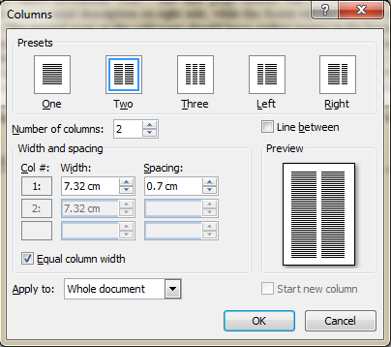
Figure 1: Figure description, Times New Roman 10, Italics, Centre Aligned

Materials and Methods:
In this section explain clearly how you conducted your study, description on experiments, materials used. Don’t mix results with procedures.

Results and Discussion:
Present the measurements made in the experiment, compare them with preliminary work or previously published results. In the discussion section you have to relate the results to initial hypotheses.

Conclusion:
Comment on how closely your measurements and calculations agree and summarise the main reasons for any discrepancies.

References:
- Basha R. H., Torii S., (2014) “Design of a computer model with enhanced feature of predicting optimum composition for biomass simulation using J2SE 5.0 program” International Journal of Earth Sciences and Engineering, ISSN 0974-5904, Vol. 7, No. 4, August 2014, pp 1619-1622
- Basha R. H., Torii S., (2014) “A numerical study on thermal performance of Biomass and its impact due to moisture for direct combustion based electricity generation” International Journal of Energy Engineering, ISSN 2225-6563, Vol. 4, No. 3, August 2014, pp 159-163
- Basha R. H., Torii S., (2014) “Use of Information Technology and Numerical methods to increase the thermal performance of Biomass based renewable fuel” International Journal of Renewable Energy and Environmental Engineering, ISSN 2348-0157, Vol. 2, No. 2, April 2014, pp 105-108

